Math 3 Unit 3

Objective: To identify end behavior of polynomial functions algebraically and graphically.

Degree of Polynomial | Leading Coefficient | Graphically | Description
Even | Positive | 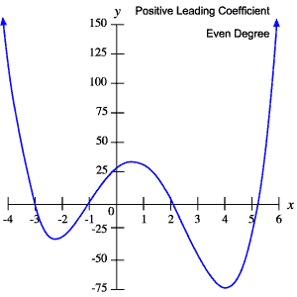 | $f\left(x\right)→+∞$ $f\left(x\right)→+∞$  $x→-∞$ $x→+∞$
Even | Negative | 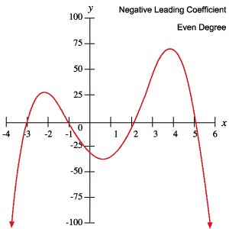 | $f\left(x\right)→-∞$ $f\left(x\right)→-∞$  $x→-∞$ $x→+∞$
Odd | Positive | 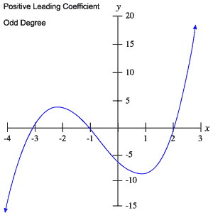 | $f\left(x\right)→-∞$ $f\left(x\right)→+∞$  $x→-∞$ $x→+∞$
Odd | Negative | 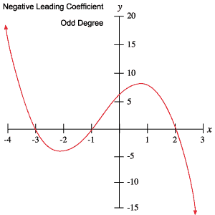 | $f\left(x\right)→+∞$ $f\left(x\right)→-∞$  $x→-∞$ $x→+∞$

Describe the degree and leading coefficient of the polynomial function. Then describe the end behavior of the graph.

1) $f\left(x\right)=x^{4}-2x^{2}+1$
The degree is _________ and the leading coefficient is _________.
$f\left(x\right)→$ ______
$x→-∞$
$f\left(x\right)→$ ______
$x→+∞$
2) $f\left(x\right)=-x^{3}-7x-6$
The degree is _________ and the leading coefficient is _________.
$f\left(x\right)→$ ______
$x→-∞$
$f\left(x\right)→$ ______
$x→+∞$
3) $f\left(x\right)=-3x^{6}+5x^{3}-7x+3$
The degree is _________ and the leading coefficient is _________.
$f\left(x\right)→$ ______
$x→-∞$
$f\left(x\right)→$ ______
$x→+∞$
4) $f\left(x\right)=x^{11}+5$
The degree is _________ and the leading coefficient is _________.
$f\left(x\right)→$ ______
$x→-∞$
$f\left(x\right)→$ ______
$x→+∞$

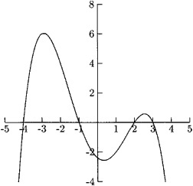
Describe the end behavior of the graph. Then describe the degree and leading coefficient of the polynomial function.
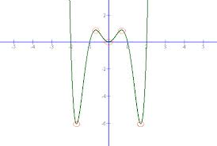
5)

$f\left(x\right)→$ ______ $f\left(x\right)→$ ______
$x→+∞$ $x→-∞$

The degree is _________ and the leading coefficient is _________.

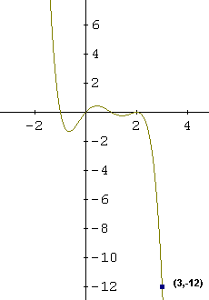
6)

$f\left(x\right)→$ ______ $f\left(x\right)→$ ______
$x→+∞$ $x→-∞$
The degree is _________ and the leading coefficient is _________.

7)

$f\left(x\right)→$ ______ $f\left(x\right)→$ ______
$x→+∞$ $x→-∞$

The degree is _________ and the leading coefficient is _________.

8)
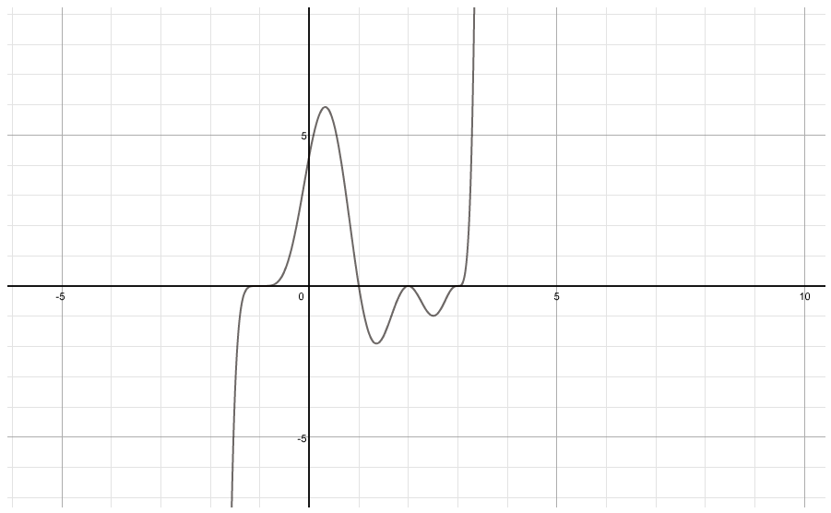

$f\left(x\right)→$ ______ $f\left(x\right)→$ ______
$x→+∞$ $x→-∞$
The degree is _________ and the leading coefficient is ________.

Use what you know about end behavior to match the polynomial function with its graph.

9) $f\left(x\right)=2x^{4}+2x-1$

10) $f\left(x\right)=2x^{2}+2x-1$

11) $f\left(x\right)=2x^{3}+x^{2}-1$
